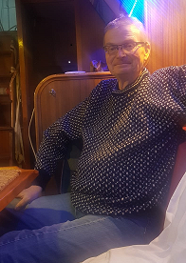
Mark Waller, Churchwarden 2024-2025
Mark was born and brought up in St Albans. Sometime Head Chorister at St Peter’s he attended St Albans School, followed by Aston University (Metallurgy and most of an MBA). He took over the family Engineering Company in 1980 and sold it in 2002. He is currently redeveloping the Engineering Works Site.

Past passions: Offshore Scuba Diving, Recumbent Cycles
Present passions: Offshore Sailing, St Peter’s Choir

Mark currently serves as Church Warden at St Peter’s (Fabric responsibilities) together with a Trustee/Chair position on three associated charities.

Married to Stella, (an Ophthalmologist), he has two children, Helen a Systems Designer and medic and Robbie a Nuclear Assurance Engineer at a Suffolk Reactor.

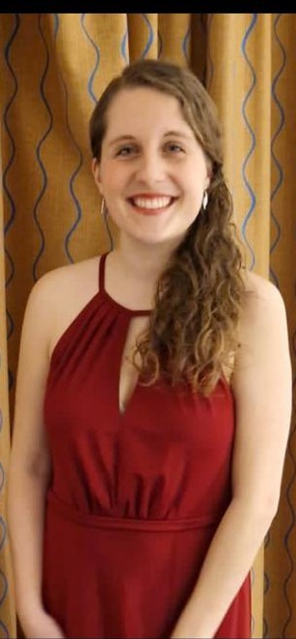
Hayley White, Churchwarden 2024-2025

Hayley Harrison - Hayley has recently moved to Harpenden with her husband David and has been attending St peter’s Church for the past 4 years. Her time here has seen Hayley support the worship at the all – age services, working with the youth and testing her skills as a bingo caller & event host to a few of our church fundraisers! Before moving to St Peter’s Church, Hayley attended St James Church in Gerrards Cross, where she volunteered as a worship & youth leader, as well as supporting the Love Africa initiatives. Hayley has been out to Uganda several times working with charities in the field. After graduating with a Music Theatre degree, Hayley uses the skills she learnt, in her role in the Financial Services industry, working for Barclays focusing on consumer behaviour and data insights. Hayley & David are preparing for their biggest adventure yet, as they are expecting their first child in June.

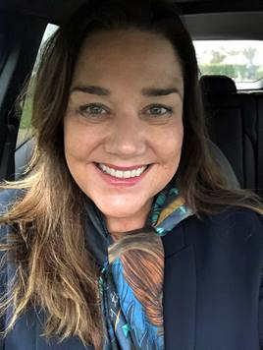
Lisa Williams, Churchwarden 2024-2025
Lisa has been a member of the congregation at St Peter’s for over 20 years and has 2 daughters, Gigi and Pippa, who were both baptised here.
Lisa and her daughters are very active in church life; Lisa has been churchwarden since 2019, and in the past has been PCC secretary, junior church leader, and a baptism visitor. Lisa is one of the volunteers who read and lead intercessions, a welcomer, and led the children’s involvement in the annual St Alban Pilgrimage for several years. She also helps with tea and coffee after our 10am Sunday services. In recent years she has also been helping the PCC with developing our Mission Action Planning and working with the flower team. Between them Lisa’s daughters have been involved in the choir, bellringing, serving, and all the children and youth groups.
At work Lisa has a busy role as full-time Partner with a global strategic marketing consultancy, and in her spare time she enjoys music, musical theatre, reading, and spending time with friends and family.

